

EXPERIMENT REPORT

|  |  |
| --- | --- |
| **Experiment Name** | Linear Applications of Operational Amplifiers |
| **Asistant Name** | Serkan Yıldız |
| **Student**  **(Name / Number / Department)** | Alihan Polat / 040110207  /Electronics and Communication Engineering |
| **Group Number and Experiment Date** | D14-26.9.2014 |

|  |  |  |
| --- | --- | --- |
| **Report Grade** | **Delivery Date** | **Acception Date** |
|  | 02.10.2014 |  |

**EXPERIMENT 4**

**Linear Applications of Operational Amplifier**

**Purpose of the experiment**

To understand the logic of operational amplifiers’ work and determination of mathematical functions that can be implemented with linear applications of operational application.

**Experiment 4.1:**

In the experiment 4.1, the inverting operational amplifier is analyzed. The gain in inverting operational amplifier gain is negative. So that we expect to see 180 degrees phase difference at the output. We constructed the circuit and measured the output by changing the value of R2 resistance for 10k, 50k, and 100k.

**R1=**10K **Input Voltage (pp) =** 2 V **f=** 1Khz **Kv = -** VOUT **/**VİN = -R2 **/** R1

|  |  |  |  |  |
| --- | --- | --- | --- | --- |
| **Resistance(R2)** | **Measured Output Voltage(pp)** | **Expected Output Voltage(pp)** | **Calculated Gain** | **Theoretically Gain** |
| 10kΩ | -1.9V | -2V | -0.95 | -1 |
| 50 kΩ | -9.4V | -10V | -4.7 | -5 |
| 100 kΩ | -19V | -20V | -9.5 | -10 |

**Experiment 4.2:**

In the experiment 4.2, the non-inverting operational amplifier is analyzed. The gain in inverting operational amplifier gain is positive. And we observed that non-inverting operational amplifier’s gain is larger than inverting operational amplifier’s gain one unit. We constructed the circuit and measured the output by changing the value of R2 resistance for 10k, 50k, and 100k.

**R1=**10K **Input Voltage (pp) =** 2 V **f=** 1Khz **Kv =** VOUT **/**VIN = 1+R2 **/** R1

|  |  |  |  |  |
| --- | --- | --- | --- | --- |
| **Resistance(R2)** | **Measured Output Voltage(pp)** | **Expected Output Voltage(pp)** | **Calculated Gain** | **Theoretically Gain** |
| 10kΩ | 4V | 4V | 2 | 2 |
| 50 kΩ | 12V | 12V | 6 | 6 |
| 100 kΩ | 21V | 22V | 10.5 | 11 |

If R2 is equal to “0” and R1 is equal to infinity from the gain formula: **Kv** = 1+R2 **/** R1 it is equal to 1. This circuit is used as a current buffer.

**Experiment 4.3:**

At the third experiment, the summing amplifier circuit is built, and then analyzed. In the experiment, 5V DC and 3V AC sin wave supplies are added as two inputs. Then the characteristic of the output is analyzed. We observed the AC signal is oscillated at -5V DC (-2 to -8 peak to peak voltage).

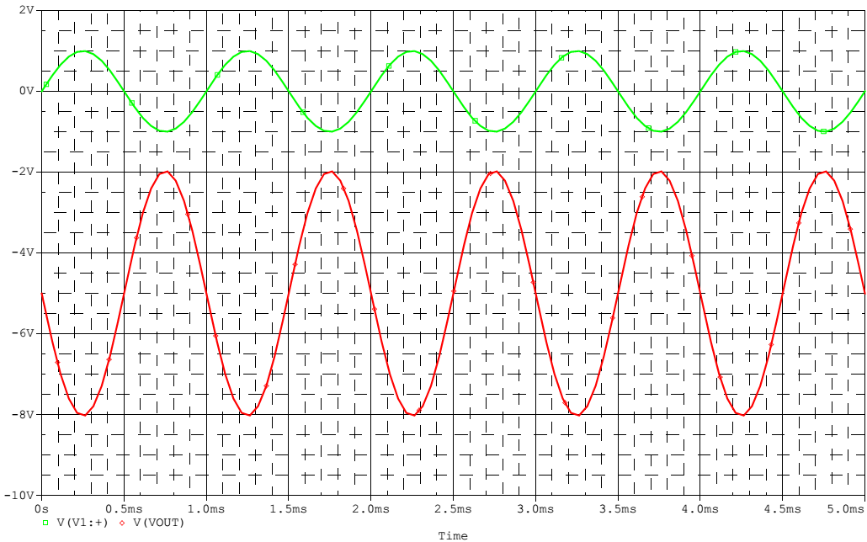

**Experiment 4.4:**

In the experiment 4.2, we constructed the differentiator operational amplifier circuit. We applied to input 2 V peak to peak 1 kHz square waves. At the output we got triangle wave. It is the differential of square wave.

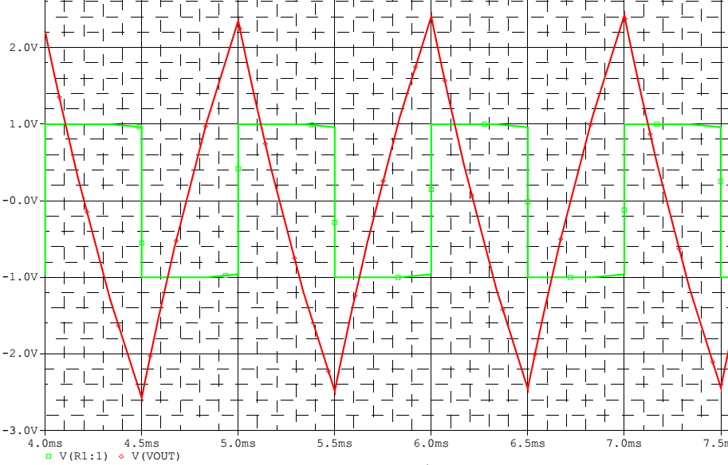

**The Common-Mode Rejection Ratio (CMRR)**

The common-mode rejection ratio (CMRR) of a differential amplifier (or other device) is the rejection by the device of unwanted input signals common to both input leads, relative to the wanted difference signal. An ideal differential amplifier would have infinite CMRR; this is not achievable in practice. A high CMRR is required when a differential signal must be amplified in the presence of a possibly large common-mode input.

**The Unity-Gain Bandwidth**

The unity-gain bandwidth of an op amp is the entire range of frequencies in which an op amp can produce gain. An op amp is able to amplify sound only through a certain range of frequencies. Once it reaches its maximum frequency in which it was designed to handle, it will then produce no gain at all after this frequency.

**Slew Rate**

The slew rate of an electronic circuit is defined as the maximum rate of change of the output [voltage](http://en.wikipedia.org/wiki/Voltage). Slew rate is usually expressed in units of [V](http://en.wikipedia.org/wiki/Volt)/[µs](http://en.wikipedia.org/wiki/Microsecond).

\mathrm{SR} = \max\left(\left|\frac{dv_\mathrm{out}(t)}{dt}\right|\right)

Where v_\mathrm{out}(t) is the output produced by the amplifier as a function of time t.